**WEB INFORMATION MANAGEMENT**

**2023/2024**

**Prof. *Massimo Marchiori***

Written by *Michael Amista’*

**Summary**

**1. Introduction to a website** 3

**1.1 The problem of “time”** 3

**1.2 The importance of structure** 6

# **1. Introduction to a website**

## **1.1 The problem of “time”**

There’s a parallelism between a website and a shop. In both there’s a window (homepage) that shows what the website/shop contains/sells.

What do the people expect from a homepage? Many things, but the most important is the **information**. The problem of information synthesis has not invented with web pages … it’s a problem common in *information communication*, the problem was born with journal articles.

The most important information components of a website homepage: **informative axes**:

* **WHERE?** Where did I (user) arrive?
* **WHO?** Who is behind the website?
* **WHY?** What are the benefits? Why should I stay?
* **WHAT?** What choices do I have?
* **WHEN?** What are the last news?
* **HOW?** How do I arrive to where I want?

That’s the **core of informatio**n, what the people want to know. If these parts are missing the information is uncompleted. Users want to know this information.

We need to convince the user to surf on our website.

**But** that’s not so easy to fill the homepage with this information. There’s a “small” problem… **TIME!** Users have expectations and have **limited time**. It’s easy to put everything on a webpage but people don’t have the time to read/see everything.

A user arrives to our homepage and he spend, on average, **31 seconds**. So, we have on average 31 seconds of time to convince the user to stay in our site and show him the information components. And the way to do it is to **compress the information**.

For example, *how much text can we put in our home page?* It depends on how much faster the people read but on average from **200 to 300 words per minute which go down to 180 in case of computer screen reader** because it reads slowly than a human.

So, if we put more than 93 words we have finished our time. They should be quite less, because the user doesn’t spend all the time just to read, but there is also time lost to analyse the visual layout, images, links and more.

**We want not only he coming to our site, but we also want him to come back!** So, what about the returning user? Same expectations? He knows you already, so the limited time for the home page will not used the axes WHERE, WHO and WHY. The time will be spent only on the remaining axes, WHAT, WHEN and HOW.

**The disadvantage of returning is more demanding**, and he has less time to spend for us.

Time on homepage: first visit (31 seconds) / second visit (25 seconds) / third visit (22 seconds) …

So, if we want to make our returning users happy, we have a little treasure of **19 seconds** four our homepage, to split among the WHAT, WHEN and HOW parts. That is a maximum of **57 words for all these components**. He will skip the parts that he already knows.

I must open a website and obtain the main information from the webpage, try with this:

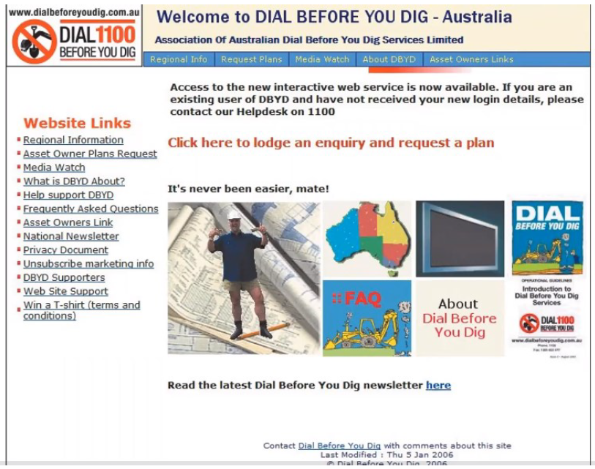

**Too hard! It’s not clear!** We can do better:

**And after the home page?** If we have success the user goes on to the other pages of the site so we cannot put everything into the homepage.

**What must we care about in the other pages?** Same thing of the homepage? NO, the user already knows where he is, so no need anymore for all the WHERE, WHO, WHY, WHAT, WHEN, HOW axes.

Once we attracted someone inside our site, we have the advantage that typically they are less likely to go away. On average, **the returning user stays more time**. From the 31 seconds of the homepage, we pass to **53 seconds**! That’s because the user entered in the shop/site, he looks at the window/homepage and now he’s inside.

This additional time allows us to add information, so having pages that are more specific than the homepage. But always remember to pay attention, and don’t exaggerate: there are always the max limits on text 🡺 53 seconds corresponding to **159 words**.

For instance, that’s the old version of the Apple website, the red box contains the 159 words (53 seconds) that the user read and then the time is over! User doesn’t know the advantages of the new iPod because that information is much later in the text.

The site has been redesigned, a lot of information to share? ***Learn more…*** after every section. It’s a user choice to know more about a feature, you’ll redirect to another webpage with another 53 seconds to spend. Every page must be designed on 53 seconds of reading. **The user choose what to do!**

There is another time that is very important for the users. **The global time is the time it takes the user to be satisfied: he found what he wanted on our site**. For instance, the global goal is to buy a new iPod and the global time is the time I spend to buy the iPod. The global time goes over the single page, it’s the experience.

The first global time is the time by which the user has got an idea on us and decides whether to stay with us (to the final goal) or to go. It’s the so-called **choice time**. The choice time is **1 minute and 49 seconds**.

When a user goes away because he’s not satisfied, we probably (88%) lose him forever. Have the best price or product is not enough, the user will go away anyway if he’s not satisfied.

The second global time is when the user expects to have found what he wanted, and so to have successfully navigated our website. This limit is **success time** and it’s about **3 minutes and 49 seconds**.

**So, what matters most is the good balancing among *homepage, internal pages* and *trail (path)* that the user follows to arrive where he wants**.

Moreover, given the success time (3m 49s), he expects to reach his goal after having seen the homepage and about three pages and a half of our site.

## **1.2 The importance of structure**

For every goal we can build the best path for the user to achieve it. The **tree structure** of our site then becomes critical, as well as the distance from the home page: from the homepage, after **one click** (max 2) we have to convince the user, and after other **two clicks** (max 3) we must give them what they wanted! We have to offer shortcuts to the goal.

The structure of the web has changed: whereas time ago navigation always usually started from the homepage, nowadays this not true anymore 🡪 to search x, navigation can start from any place (Google), this is called **deep linking**. The user can see an internal page before the homepage and he cannot see the homepage never. For us this is a challenge!

The situation is therefore more complex: **each page can be the first page that a user sees**. So let’s see what happens to the axes: some axes become mandatory, others optional, and others can be omitted.

**Mandatory informative axes**:

* **WHO** (typical shortcut: logo in the upper-left part)
* **WHAT** (typical shortcut: direct link to the home page)

Optional informative axes:

* **WHEN** (completely optional)
* **WHY** (suggested!) == short description
* **HOW** (suggested!) == typical shortcut: the search functionality (preferred position up-right part). Suggest to insert correlated pages.

The most important informative axes is **WHERE** because the user is “thrown” in the middle of our information forest 🡪 typically we should make clear the context.

Why WHAT is not enough? To avoid for the user to always go to the homepage, wasting a click. **If the user directly lands on a certain page, we have more information on what he wants!** Let’s use that information, instead of pushing him back to the home page.

*Example*: if a user entered in a shopping page where he can buy a tv we can put a shortcut like “Do you want see other electronic products?” to avoid the user goes to the homepage.

**Typical error: put the homepage menu in a specific page**.

The user doesn’t care about the global functionalities in a specific page. He prefers knows what he can do inside that page and for the entire menu I can put a shortcut to the homepage.

These techniques, that explain to the user where he is, are called **breadcrumb**. Three main kinds of breadcrumbs (we can use just one or all three):

* **Location**: where we are (Home >> News >> News x). It helps the people to navigate in the website;
* **Attribute**: shows the attributes of the given page, so it does not necessarily correspond to the location, but contains the path from the main type and its subtypes (for example a component sales site may have HW / graphics cards / nvidia / geforce). Each page has tags that help understand the categorization;
* **Path**: show the path taken by the user to arrive to the page. Typically they are dynamical.

The classic separators for breadcrumbs are two: “>” and “/”.